DATABASE AND MANAGEMENT SYSTEM TH/LAB



**UNIVERSITY OF ENGINEERING AND TECHNOLOGY, TAXILA**

**DEPARTMENT OF SOFTWARE ENGINEERING**

**PROJECT: CRICKET MANAGEMENT SYSTEM**

**Instructor**

Ma’am Saima Zareen & Ma’am Rabia Arshad

|  |  |
| --- | --- |
| **Name** | **Registration No** |
| Ghufran Ullah | 20-SE-34 |
| Muhammad Ali Mian | 20-SE-74 |

**Date:** 16th Jan 2023

**Table Of Contents**

▪ **Aims & Objectives** 3

▪ **Tools used/to be used for implementation** 3

▪ **GUI Explanation:** 3

o **Team Information’s:** 3

o **Player Details:** 3

o **Match Details:** 3

o **Ground Info:** 4

o **Admin:** 4

▪ **Conclusion** 23

▪ **References** 23

**DESCRIPTION OF CRICKET MANAGEMNT SYSTEM**

# **Aims & Objectives**

Our objective is to design a Cricket Management system using database Oracle and using this software we can manage and store data about any match series and handle the data effectively Our objective is to use the NETBEANS and ORACLE SQL to create PSL Management system.

# **Tools used/to be used for implementation**

NETBEANS (Java Language Compiler)

ORACLE SQL (Database creation tool)

# **GUI Explanation:**

In this system GUI start with Menu where user will have several options regarding this system. Like if he/she will have access to see following details about players etc. added in a system.

* Team Information
* Player Details
* Matches Details
* Ground Info
* Admin

## **Team Information’s:**

We are simply displaying data of teams like how many teams are there in our system currently. In this menu you can also see one more feature which is displaying the details about coach and managers using join on two table to fetch data from two different tables.

## **Player Details:**

In this menu you can see all the players that are added in a team and their all records. If you want to see all player that belongs to any particular team you also can do this here. One more feature that we have added the concept of nested query to display that which player has highest no of 50’s and 100’s.

## **Match Details:**

We are simply displaying Match details like which teams are going to compete with each other etc. In this menu we again used the concept of join to join two tables Schedule & Match to display the required entries that we are interested in to display the schedule of all matches which consist of Time and Place.

## **Ground Info:**

In this menu we are displaying all the ground details which user can see.

## **Admin:**

This is strictly only for admin. Admin need to login then he will have access to different options. Like,

* Admin can only see viewer details like their CNIC etc. and many more.
* Moreover, Admin have access to update any field like
* Can update Ground capacity in Ground Details.
* Can update match type and venue of any match.
* Can update player 50’s and 100’s and also change player team.
* Can update team captain and coach name.
* Can update viewer details like CNIC and contact no.
* Admin has also access to delete any player (Using procedure) from system just need to enter that player ID.

**GUI**

**HOME**

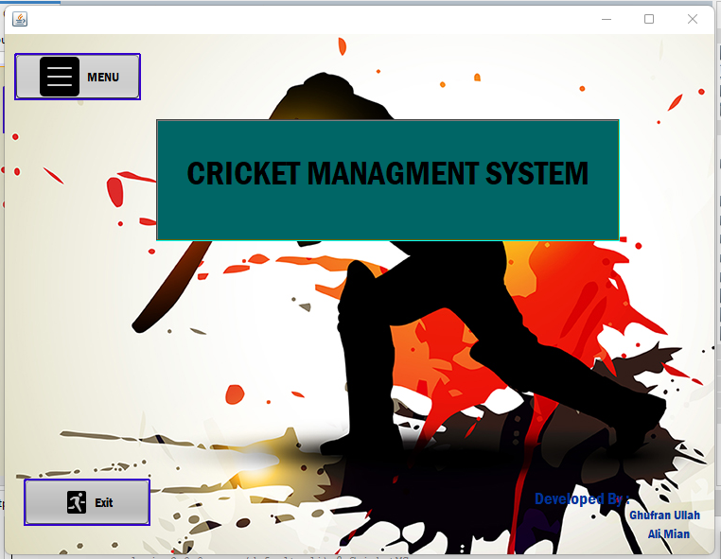

**Menu**

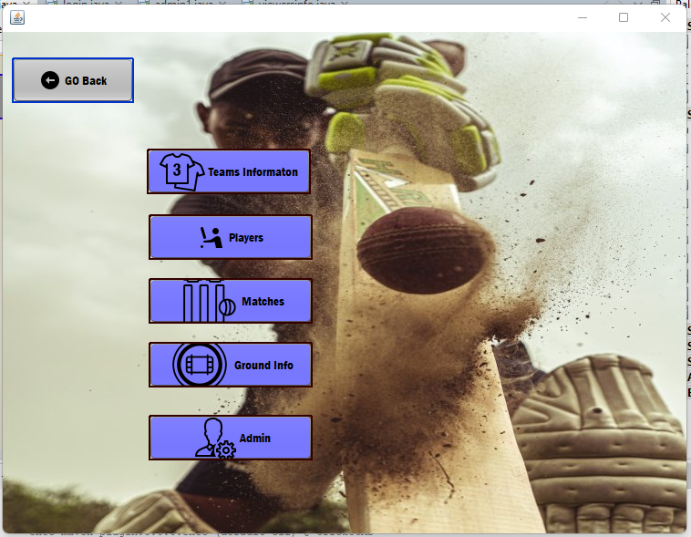

**Team Information’s**

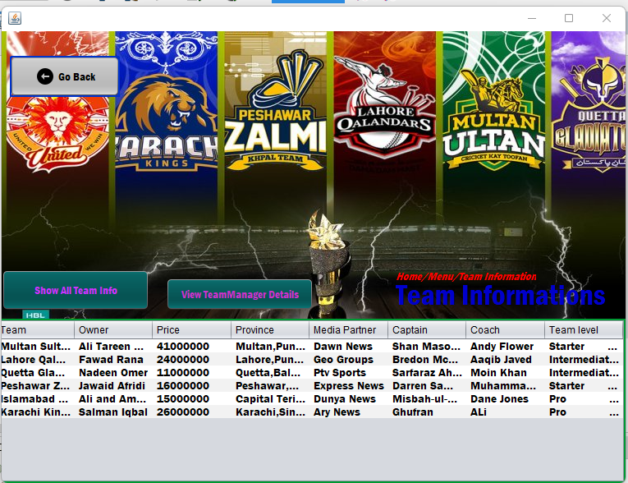

**View team Manager Details:**

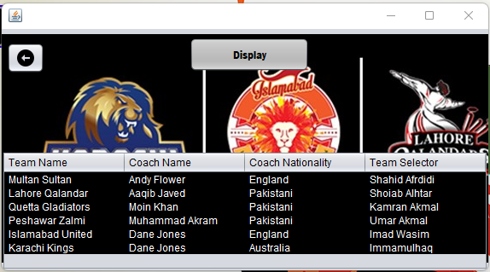

**Players Information’s**

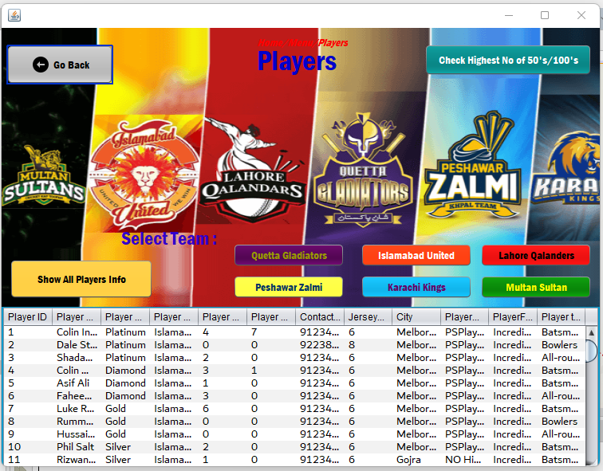

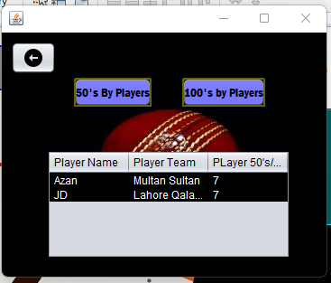**Highest 50’s by Players**

**Quetta Gladiators Players**

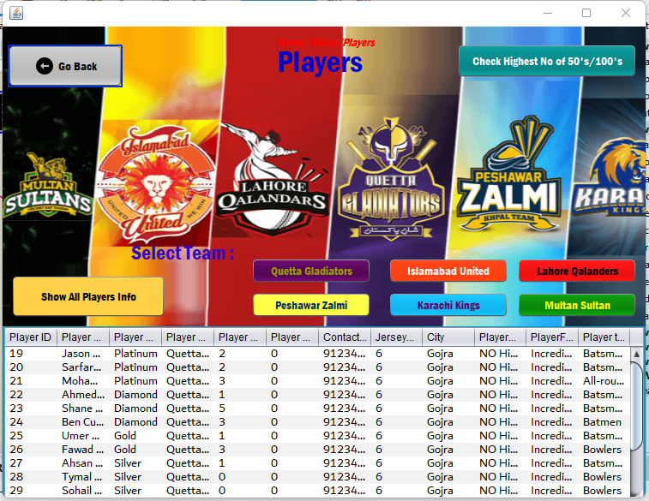

**Match Details**

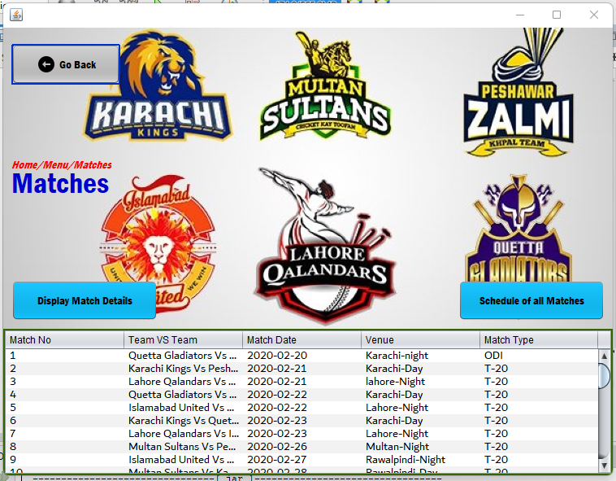

**Schedule of Matches**

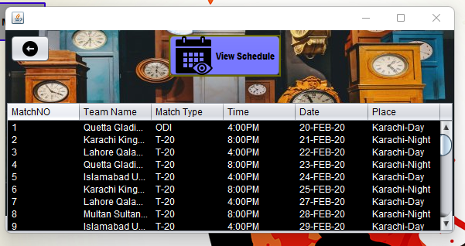

**Ground Information’s**

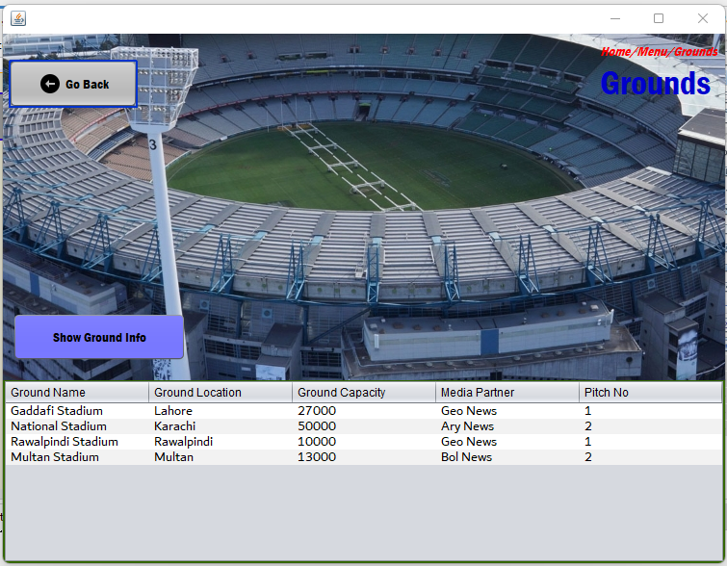

**Admin**

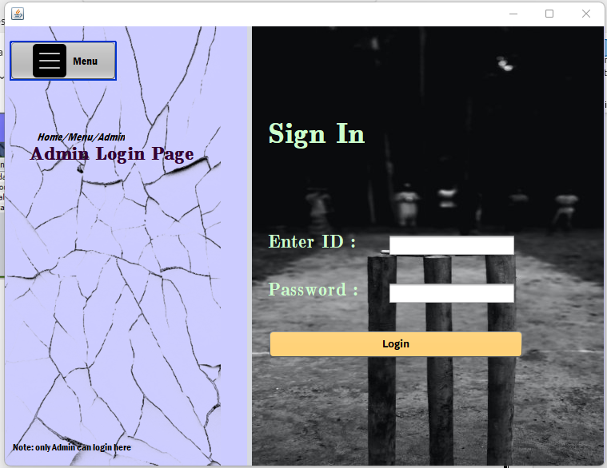

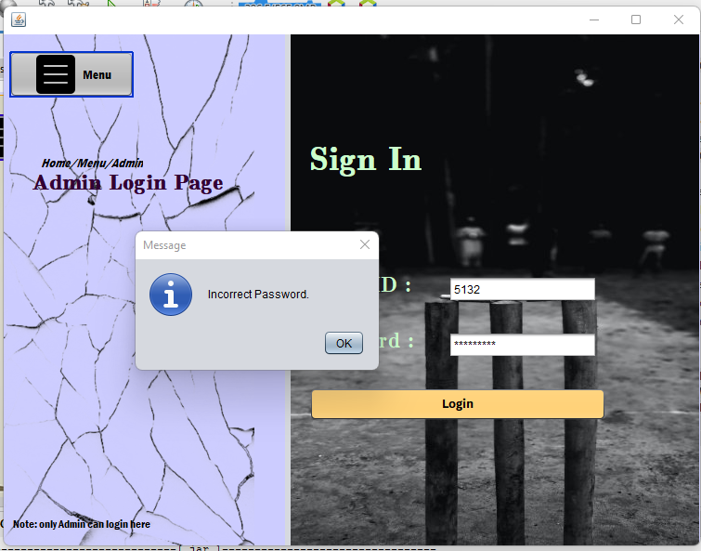

**Admin menu**

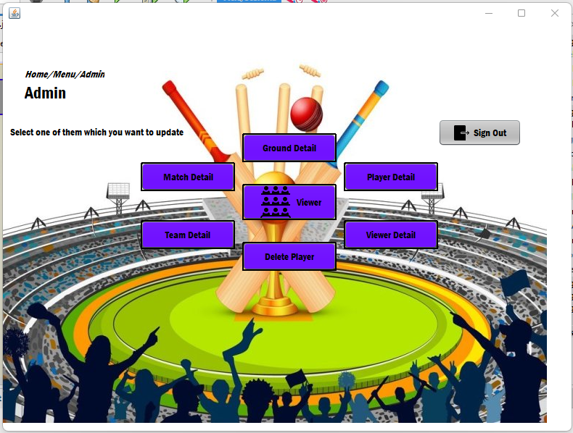

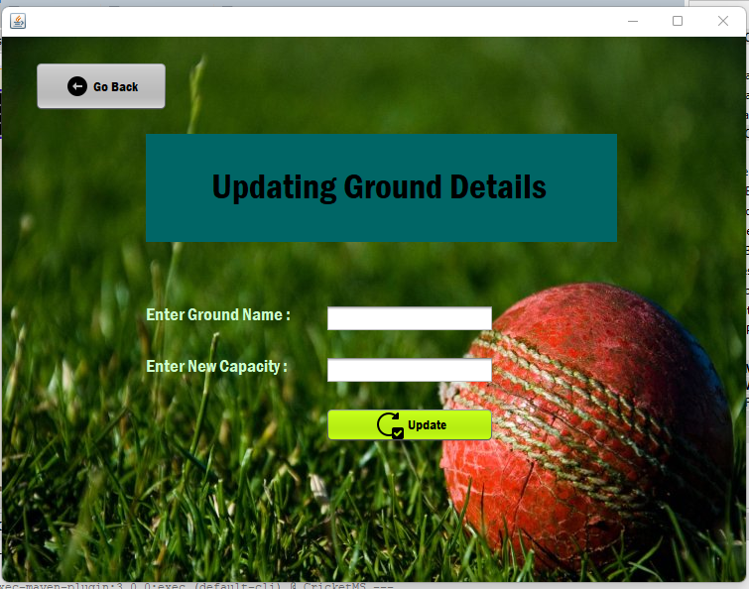

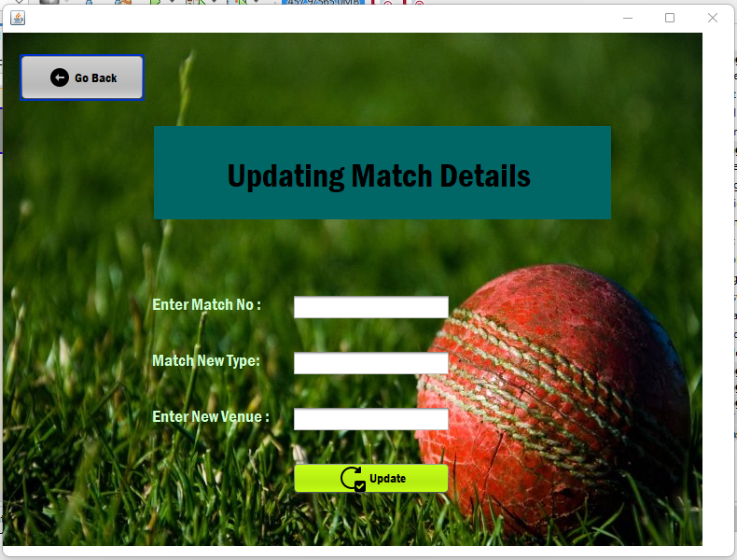

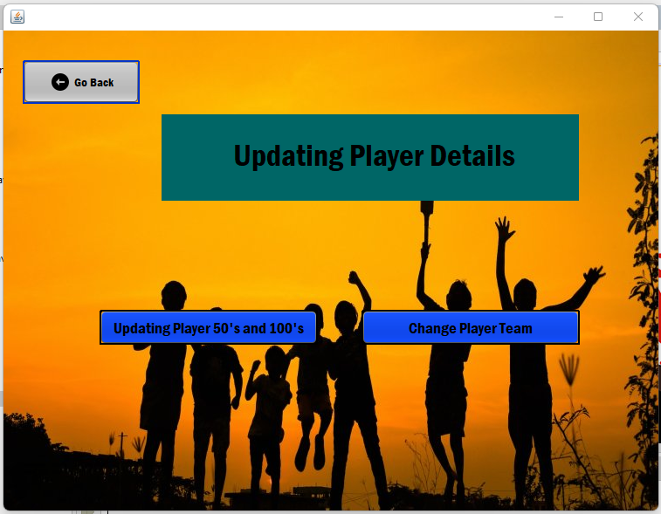

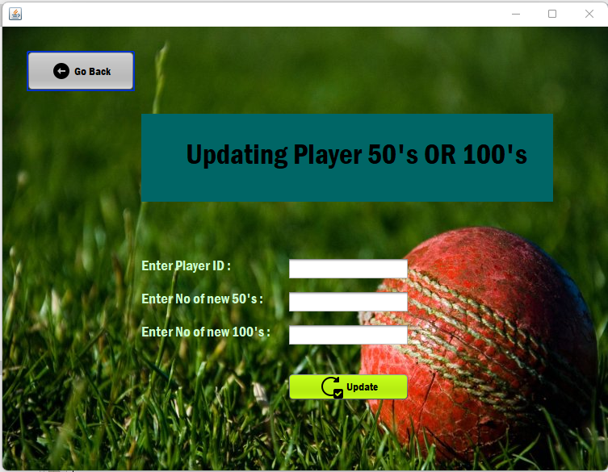

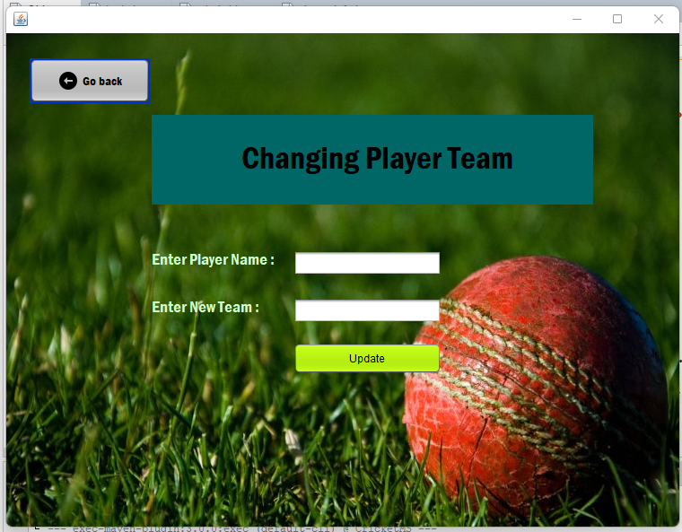

**Viewer details**

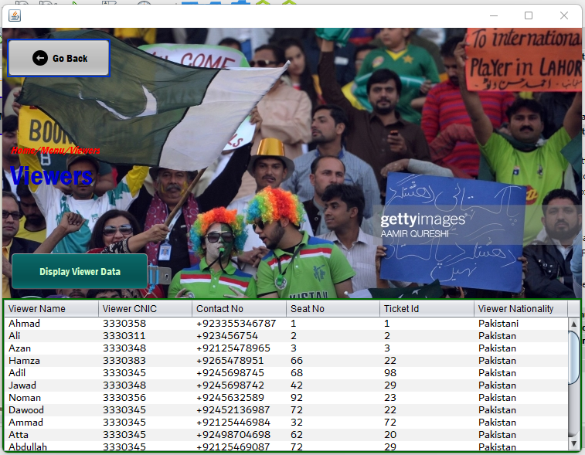

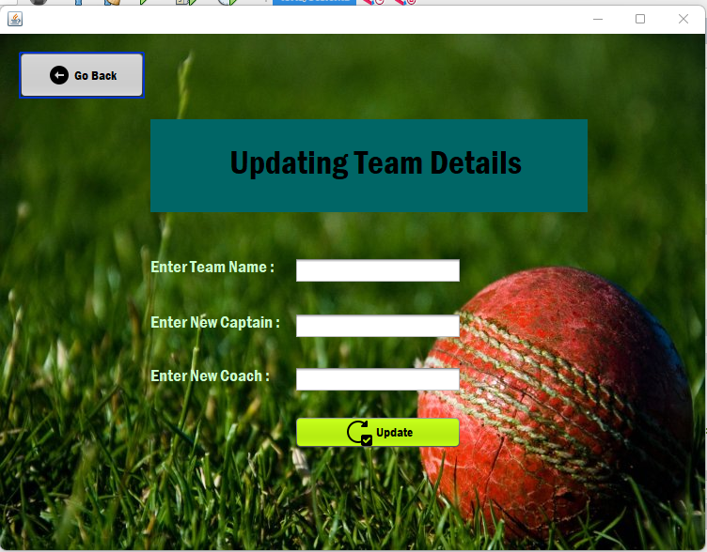

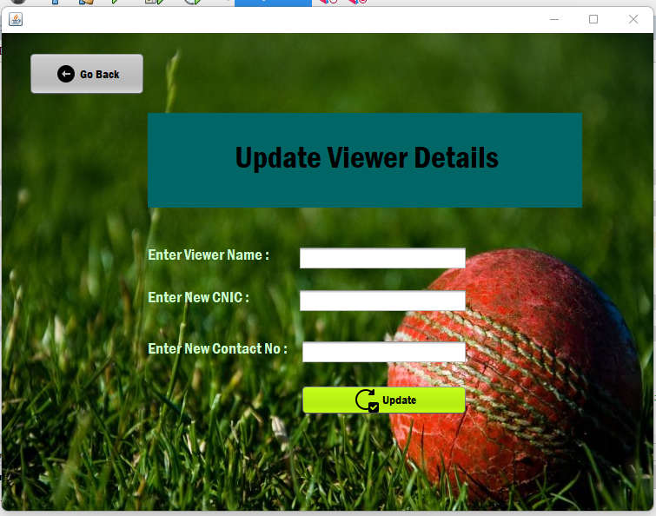

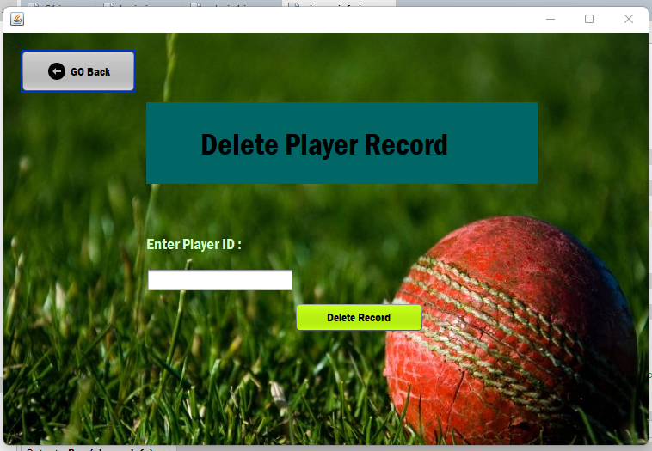

# **Conclusion**

Security is essential in any Information system to protect the information of players which is provided in our system as well as our system also allows data checking at the time of input so that the only valid data can be entered in the system. It also allows the user to manage all data effectively.

# **References**

*Pakistan Super League Cricket Team Records & Stats | ESPNcricinfo.com*. (n.d.). Cricinfo. https://stats.espncricinfo.com/pakistan-super-league-2016-18/engine/records/batting/most_runs_career.html?id=205;type=trophy

*Pakistan Super League Cricket Team Records & Stats | ESPNcricinfo.com*. (n.d.-b). Cricinfo. https://stats.espncricinfo.com/pakistan-super-league-2016-18/engine/records/bowling/most_wickets_career.html?id=205;type=trophy

Staff, E. (2015, September 24). *Dubai, Sharjah venues for Pakistan Super League*. ESPNcricinfo. https://www.espncricinfo.com/story/dubai-sharjah-venues-for-pakistan-super-league-923067

Nauman, Q. (2016, February 23). *Pakistan Super League: Twenty20 Underdogs Quetta Gladiators Emerge as Favorites in Final*. WSJ. https://www.wsj.com/articles/BL-IRTB-31505